**Chapter 3**

**The Proposed System**

**3.1 Project Overview**

The expected basic physical view of the On Hand Keyboard and Mouse is, it’s a wearable glove which will attach all the required circuits, contact points and other components on it. Therefore it can call as ''Key Glove''. The basic concept of the Key glove is to generate input signals by touching unique combinations of conductive touch points together. These touch points are mounted on the fingers and palm of the glove in strategic places to allow for the greatest possible number of combinations. Some of these combinations are more physically difficult than others, and so these are intended to be used much less frequently or even not at all. The glove also has an accelerometer on the back, which will be used to control mouse movements. The concept is to have a particular ''mouse-on'' touch combination, which will then start watching the multi-axis tilt or motion of user hand and then translate that into mouse cursor movements.

Due to the limited number of keys can be placed on finger segments, expected system has assigned three characters per finger segment and thumb can be used to touch each finger segment. User can type characters by one, two or three finger strokes on finger segments and strategically and ergonomically combination of finger strokes with each finger segments, can be assigned a lot of character output from limited number of keys. Therefore key arrangement and allocation of characters depend on the characters or function priorities (Frequently used and rarely used).

This system can be used in office tables which have limited space for working and also it can be used in areas as varied as the military, Space activities, gaming, making music with the use of a synthesizer. And some people they can’t control the motions necessary for typing on a regular keyboard or using a regular mouse. So this design is such that it can be overcome many of these problems and give some computer control back to people who have lost it. Furthermore it has lot of applications over the conventional keyboard and mouse. Addition to that, this system has the capability of adding different extra features with proper interfacing techniques to have user specific or application specific solutions.

**Chapter 4**

**Conceptual Design**

**4.1 Introduction**

As mentioned above the general operation of the proposed system will be a new type of input devise which has more flexible and useful features over the conventional systems. In this chapter Overall system design is explained.

**4.2. System Block Diagram**

**Display**

**MCU**

**Hand Movement detection**

**Computer**

**Switching Matrix**

**Key matrix**

**Mouse Controller**

**Keyboard Encoder**

**Figure 4.1**: System Block Diagram

**4.2.1 Hand movement detection**

This system is used hand movements as the input method and accelerometer is the sensor to detect hand movements. For the movement analysis, it is needed to somehow translate the accelerometer tilt angle data to displacement of mouse cursor. There are two main methods when calculating the new cursor position:

* Absolute mapping in which every tilt angle corresponds to a position on screen
* Relative mapping in which every tilt angle corresponds to a hand displacement

Tilt information is measured by accelerometers on this unit, which export analog voltages to interface circuit through microcontroller.

**4.2.2 Accelerometer Sensor**

The implementation of mouse is centered on the analog devices ADXL335 triple axis accelerometer. Accelerometer is a sensor or a transducer which converts the effects of mechanical motion into an electrical signal that is proportional to the acceleration value of the motion. The basic principle of accelerometer based positioning is double integration of accelerations to changes in position.

The ADXL335, a near ideal kind of vibration sensor, eliminates significant problems with existing vibration sensors, such as piezoelectric and bulk capacitive sensors. Primary benefits derive from much lower cost, stable sensitivity as a function of frequency and temperature, ruggedness and easy to use. Besides machine health and condition monitoring, it is particularly well suited for noise and vibration cancellation applications.

The ADXL provides both static (gravity) and dynamic (vibration) information which can be used to indicate the exact orientation of the main system. The ADXL335 provides two forms of data output; duty cycle and analog voltage. For this design, the analog voltage output is used and is connected to the A/D channels of the MCU. On power up, the micro controller records the static acceleration values and thereafter continuously tests new acceleration data. By analyzing A/D converted value, the microcontroller can identify the direction of motion whether is it UP-Down or Left- Right motion.



**Figure 4.2**: Accelerometer sensor unit

**4.2.3 Key matrix and Switching matrix**

Key matrix is the Key board which it is Combinations of Keys on hand glove. Touch Points are mounted on the fingers and palm of the glove in strategic places to allow for the greatest possible number of combinations. To make the contact points or touch points on the glove, conductive thread and conductive fabric was used.

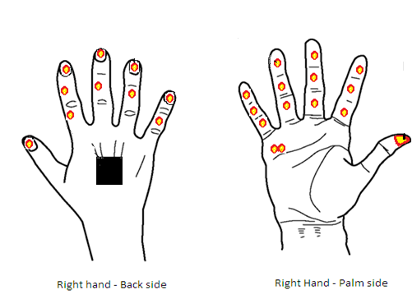

**OPQ**

**LMN**

**Mouse selector**

**Backspace**

**345**

**89**

**UVW**

**67**

**IJK**

**CDE**

**Enter**

**012**

**RST**

**Delete**

**L click**

**FGH**

**Caps lock**

**AB**

**.+-**

**=/\***

**[ , ]**

**XYZ**

**R click**

**Main Touch Point (+)**

**Space**

Accelerometer

**Figure 4.3**: Positions of the Touch points and Accelerometer

The outputs of the touch points are transmit through the interface circuit to the MCU. In the MCU, corresponding Row and column combination are decided and then activate the Switching Matrix and Key Encoder. After that Key encoder transmits data to the computer for further process and finally displays the character. The Figure 4.3 shows the positions on the hand for the Touch points and the Accelerometer.



**Figure 4.4** : Schematic of the Switching matrix

**4.2.4 Keyboard Encoder**

The Keyboard encoder is an interface devise which made interface between Key matrix and the computer. It converts corresponding key combinations in Key board in to the data format which need to send to the computer. In this devise the NMBK15R4286 encoder is used. It can function in PS2 interface environment.



**Figure 4.5**: Schematic of the Keyboard encoder circuit

**4.2.5 Mouse controller**

The EM8451 Scrolling Mouse Controller is specially designed to control PS/2 mouse device. By using this controller and Accelerometer with microcontroller can obtain the mouse operation. In this project, according to the hand movements the accelerometer data are send to the microcontroller and in the microcontroller, process this data and corresponding control signals are send to the mouse controller. Then mouse controller which connecting with the computer obtain the mouse operation. So the main function of the Mouse controller is communication interface between the computer and the System. The Following figure shows the circuit diagram of the Mouse controller. .



**Figure 4.6** : Schematic of the Mouse controller circuit

**4.2.6 Micro Controller Unit (MCU)**

The brain of this system is the Microcontroller unit. The Analog to Digital Convertor is taken the signal and converts it to a binary code. This way a computer can recognize the signal in a digital format. Mouse status information from the measured accelerations and position are analog voltages. These voltages are converted into digital signals by the Analog-to-Digital Converter (ADC) of a microcontroller and processed signals are send to the Mouse controller. The output of the key matrix, which character should send to the PC according to the key combination on the Glove is determined by the MCU and controlled the switching matrix. After the main process related to the system, these signals are send to the computer through the PS/2 Port for mouse and Keyboard operation.

The Arduino Mega 2560 is a microcontroller board based on the ATmega2560. It has 54 digital input/output pins (of which 14 can be used as PWM outputs),16 analog inputs, 4 UARTs (hardware serial ports), a 16 MHz crystal oscillator, a USB connection, a power jack, an ICSP header, and a reset button. It contains everything needed to support the microcontroller; simply connect it to a computer with a USB cable or power it with a AC-to-DC adapter or battery to get started. In this project I used this microcontroller board as the brain of the system.

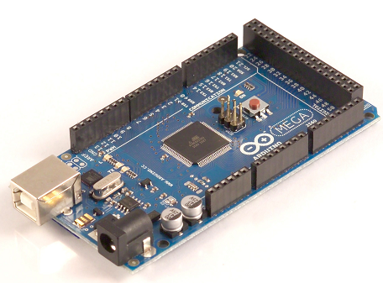

**Figure 4.7**: Microcontroller circuit (Arduino mega - 2560)

**4.2.7 Technical Specification**

* Microcontroller ATmega2560
* Operating Voltage 5V
* Input Voltage (recommended) 7-12V
* Input Voltage (limits) 6-20V
* Digital I/O Pins 54 (of which 14 provide PWM output)
* Analog Input Pins 16
* DC Current per I/O Pin 40 mA
* DC Current for 3.3V Pin 50 mA
* Flash Memory 256 KB of which 8 KB used by boot loader
* SRAM 8 KB
* EEPROM 4 KB
* Clock Speed 16 MHz

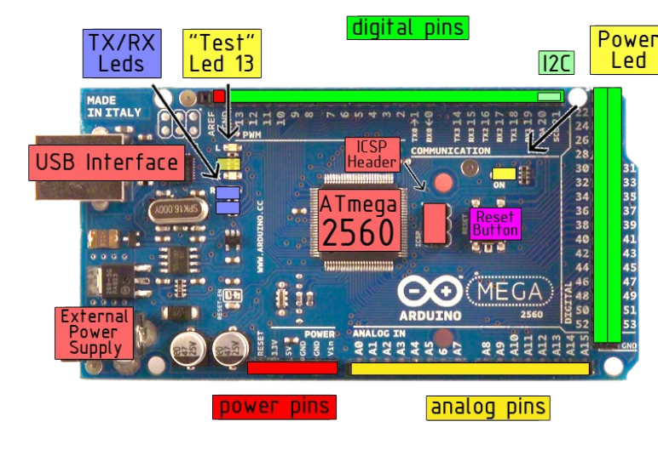

**Figure 4.8**: Sections of the Microcontroller board.

**4.2.8 Computer**

The computer contains the system mouse and keyboard drivers, when PS/2 cable connects to computer it can be recognized as an actual mouse and key board. The system uses accelerometers to detect the user's hand movement in order to direct mouse movement on the monitor in real time through the PC and key matrix’s outputs also communicate with PC through PS/2 port and display on the monitor.

**4.3. Functional Block Diagram of the Mouse**.

Start

Initialized the

System

If Mouse selected

Accept Mouse

Data

Read analogue, X and Y

Directions data from

Accelerometer

Analogue to

Digital

Conversion

Key board

Function

Activate

Send Mouse control signals to mouse controller

Yes

Keyboard LED

ON

Mouse LED

OFF

Keyboard LED

OFF

Mouse LED

ON

Check Mouse

Click

Statements

No

**4.4 Functional Block Diagram of the Keyboard.**

Start

Check the

Glove's Key

Activation

If any touch Point

Active

Count Number of

Clicks (K) on the

Touch Point

If K= 1

If K = 2

If K = 3

If K= 4,5 or 6

K-3

Select Corresponding Row & Column of the Key matrix

Active Key Encoder

Send Data to

Computer through

PS/2 Port

If SW0= Open

End

Yes

Yes

Yes

Yes

Yes

Yes